## Wireframe Interactivity Breakdown

The aim of this document is to breakdown the wireframes created for my final year university project and detail some of the interactions between my wireframe artboards.

The following artboards were all made using Adobe XD and are labelled to discuss the positioning of my app features.

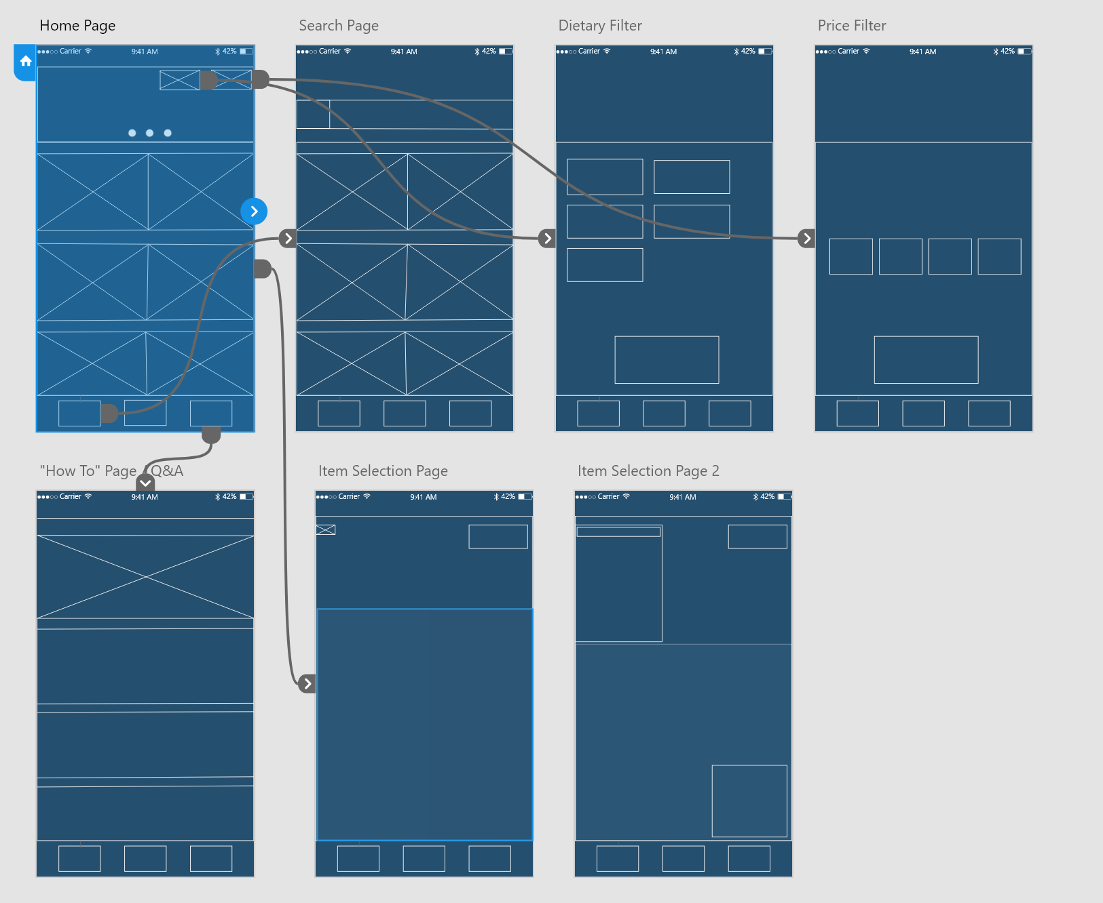

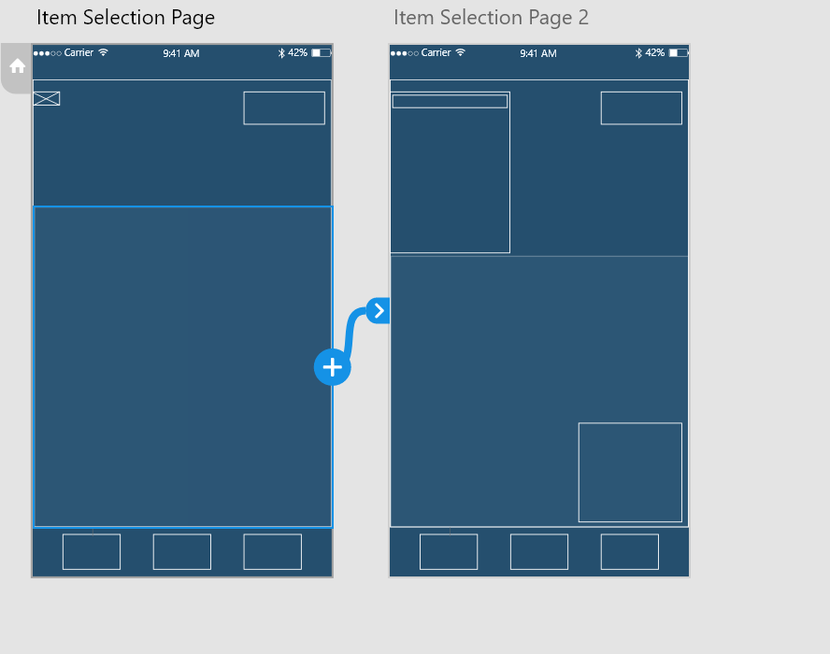

The above two images show a very brief overview of my wireframes and the interactions seen between them. As you can see from the first image, the ‘Home Page’ artboard connects to every single other page except ‘Item Selection Page 2’, which can only be accessed from the original ‘Item Selection Page’. This is shown in the second image attached above.

# **Home Page**

A button to access the price filter page.

Welcome images for the app itself, can include menu products or menus.

These are the restaurants themselves. Attached will be the restaurants image and the restaurant name above their image. This should involve an infinite scroll option to see all possible products.

A ‘search’ button that leads the user to the search page. Users should be able to search for products or restaurants.

A button to access the help-page. This shows the user how to use the app and common questions users may have about the app.

This is the ‘Home Page’ button. When selected in any other page other than the home page, it should re-direct the user back to this page. If selected in the home page, nothing should happen.

A button to access the dietary filter page.

# **Dietary Requirements Page**

This page aims at helping users filter out restaurants that do not meet their dietary requirements. This could include: Vegan, Vegetarian, Gluten-Free, Kosher, Halal.

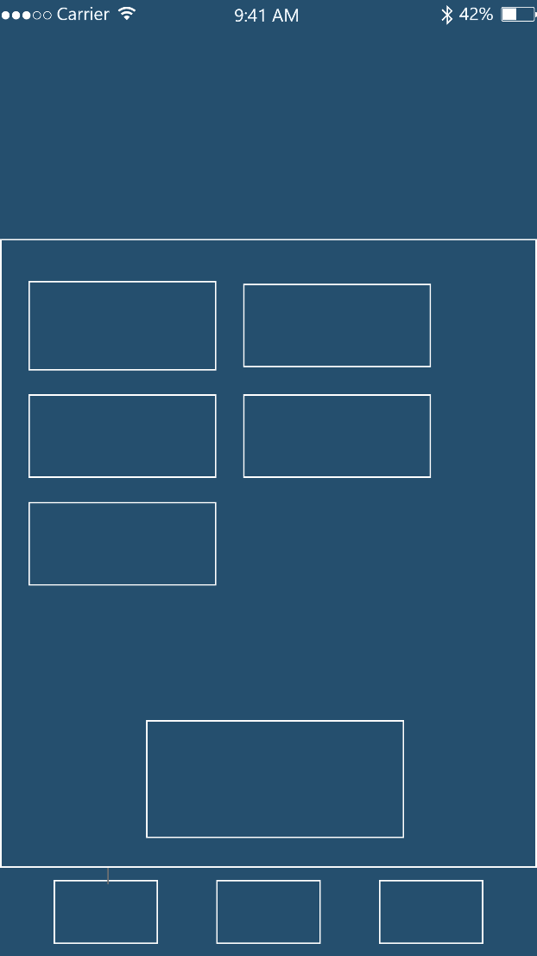

The selection of buttons clickable by the user. Each one will apply a relevant filter to what people want.

The ‘Home’ button to return to the home menu itself.

The ‘Apply’ button to apply the relevant filter attached.

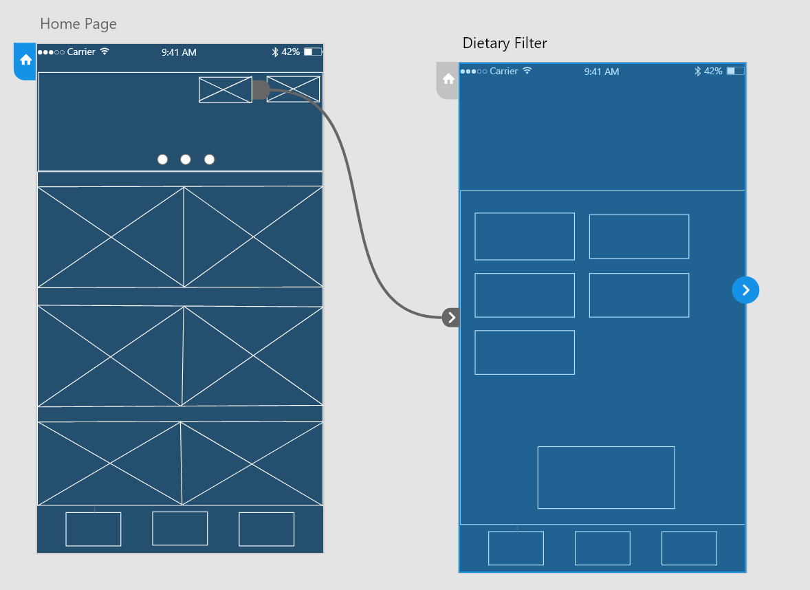

Attach above is the wireframe interactivity between the Home Page and Dietary Filter connection.

# **Price Filter Page**

This page aims at helping users filter out restaurants based on their price. This ranges from £ - £££ in price range (where £ is the cheapest options and ££££ is the most expensive).

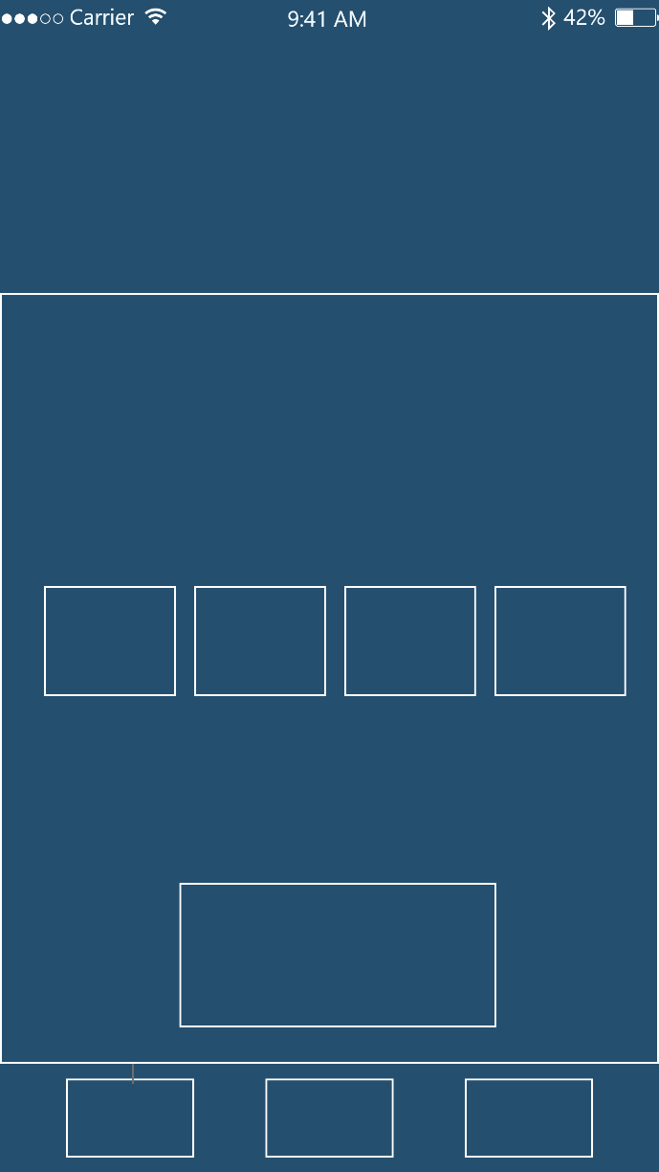

Most expensive price filter, as the most expensive filter.

Cheapest price filter

Apply button.

Home Menu button.

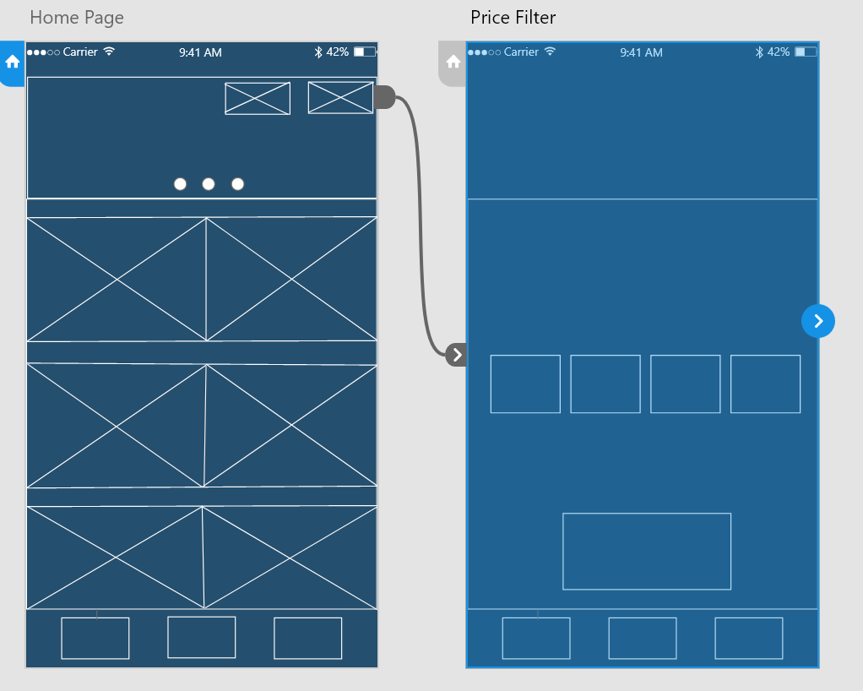

Interactions between the Home Page and the Price Filter page.

# **Search Filtering**

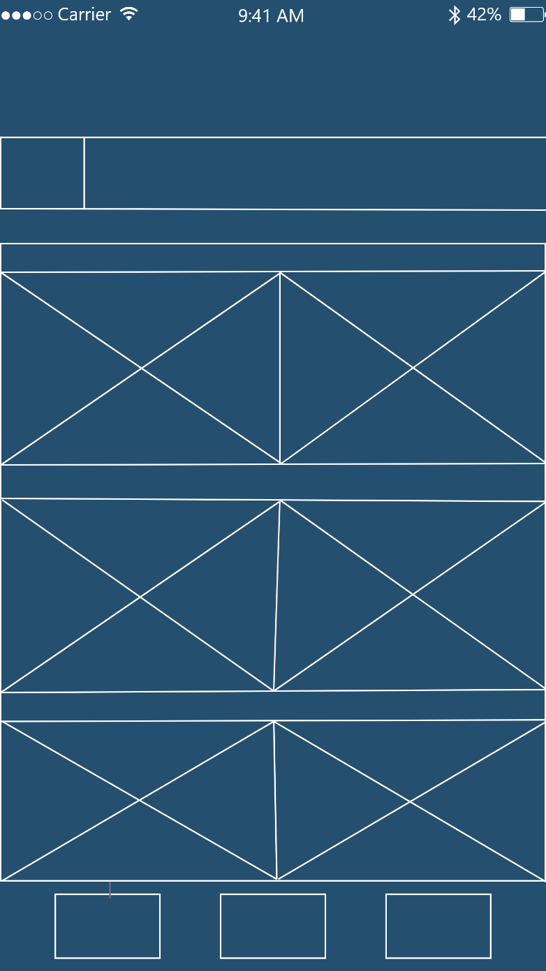This page aims at helping users manually search for specific products or menus from a list, if they can’t find them manually.

A list of restaurants as found from the home menu page.

A search bar to type in products or restaurants to look for. Relevant restaurants that match the search item or menu should appear.

The Home Menu button.

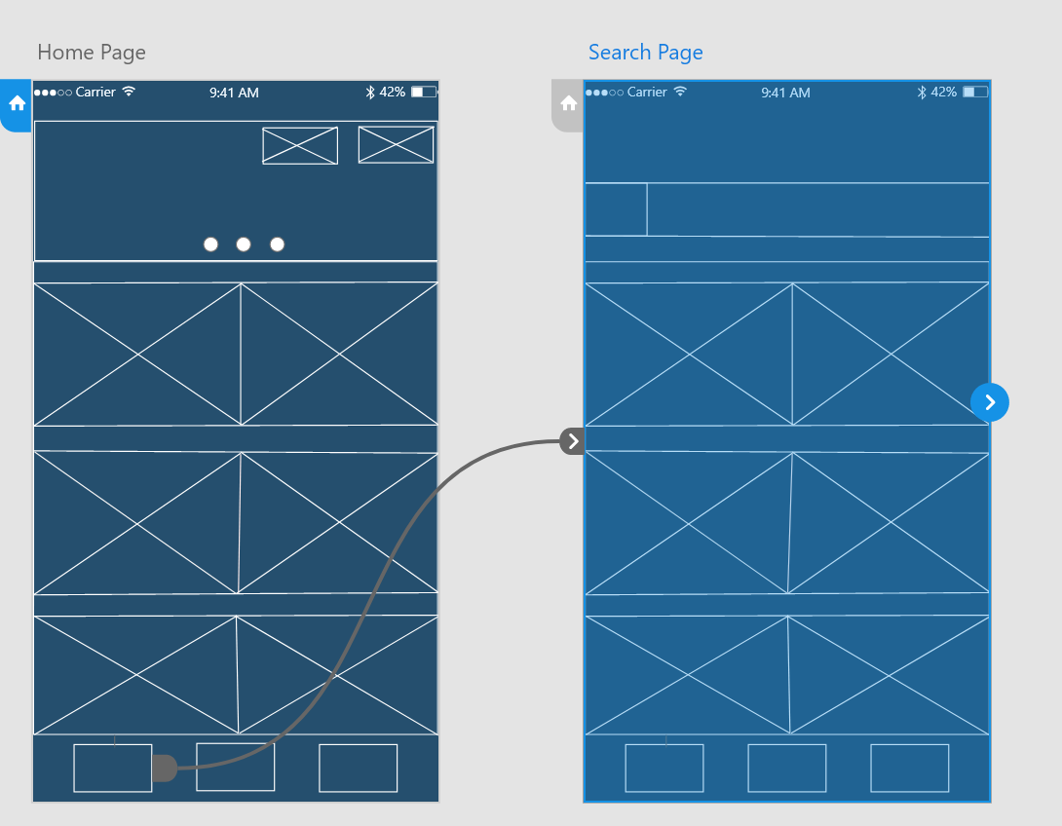

Interactions between the Home Page and the Price Filter page.

# **How-To Page**

This page aims at helping users find their way around the app. Including:

* How to use the app
* Where to select items from
* How to get to the right pages
* Common FAQ questions.

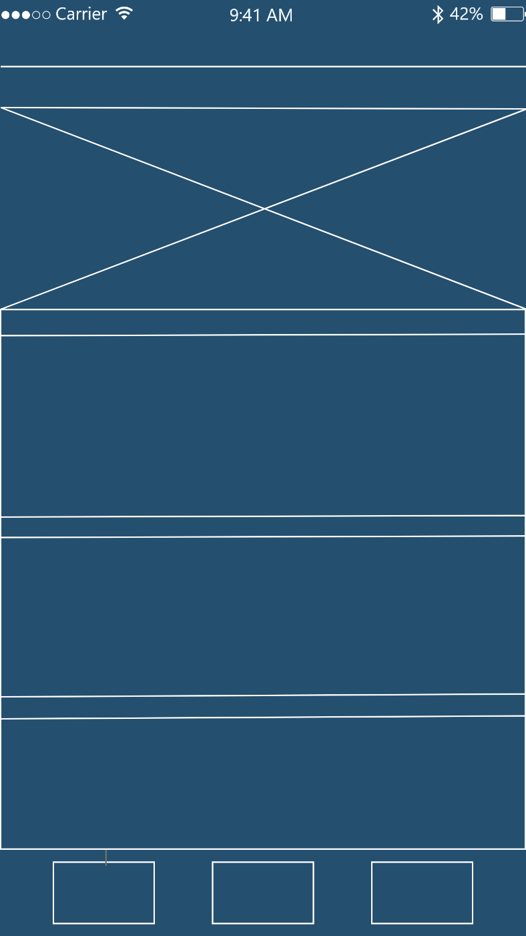

The FAQ section with relevant questions and answers regarding how to use the app.

An instructional image guide showcasing how to navigate through the app.

The Home Menu button

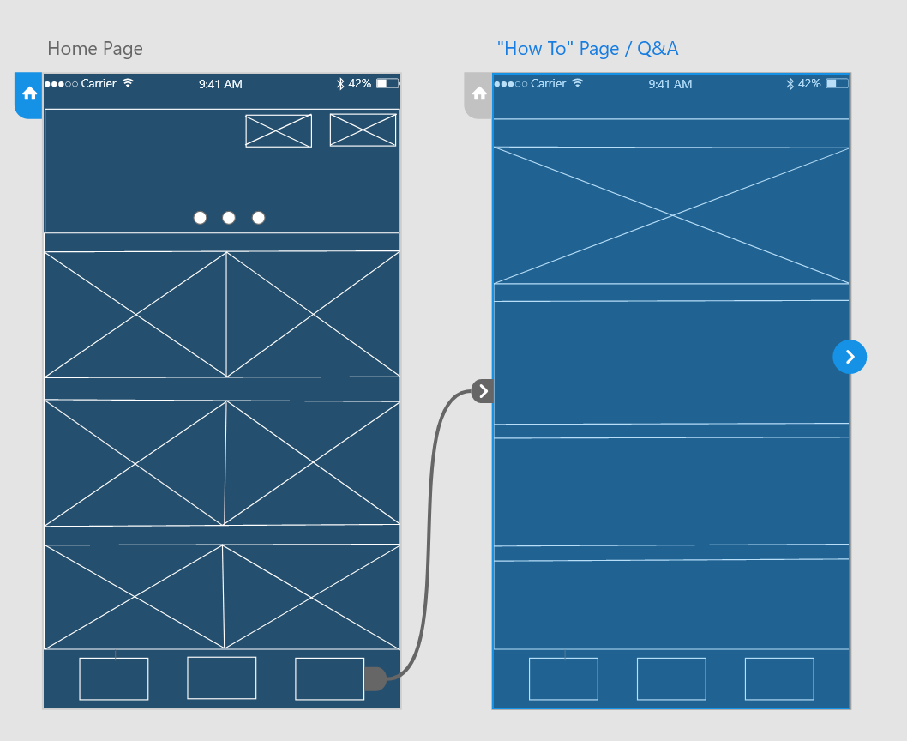

Interactions between the Home Page and the “How To” Page.

# **Item Selection page**

This page is where the majority of functionality arrives from my application.

Users should be able to select an item from a menu (that they will have previously selected), and then place the product on an AR plane and view it in a range of different angles.

Users should also be able to clear all instances of items placed on the AR plane or click the home menu button to go back to the original page.

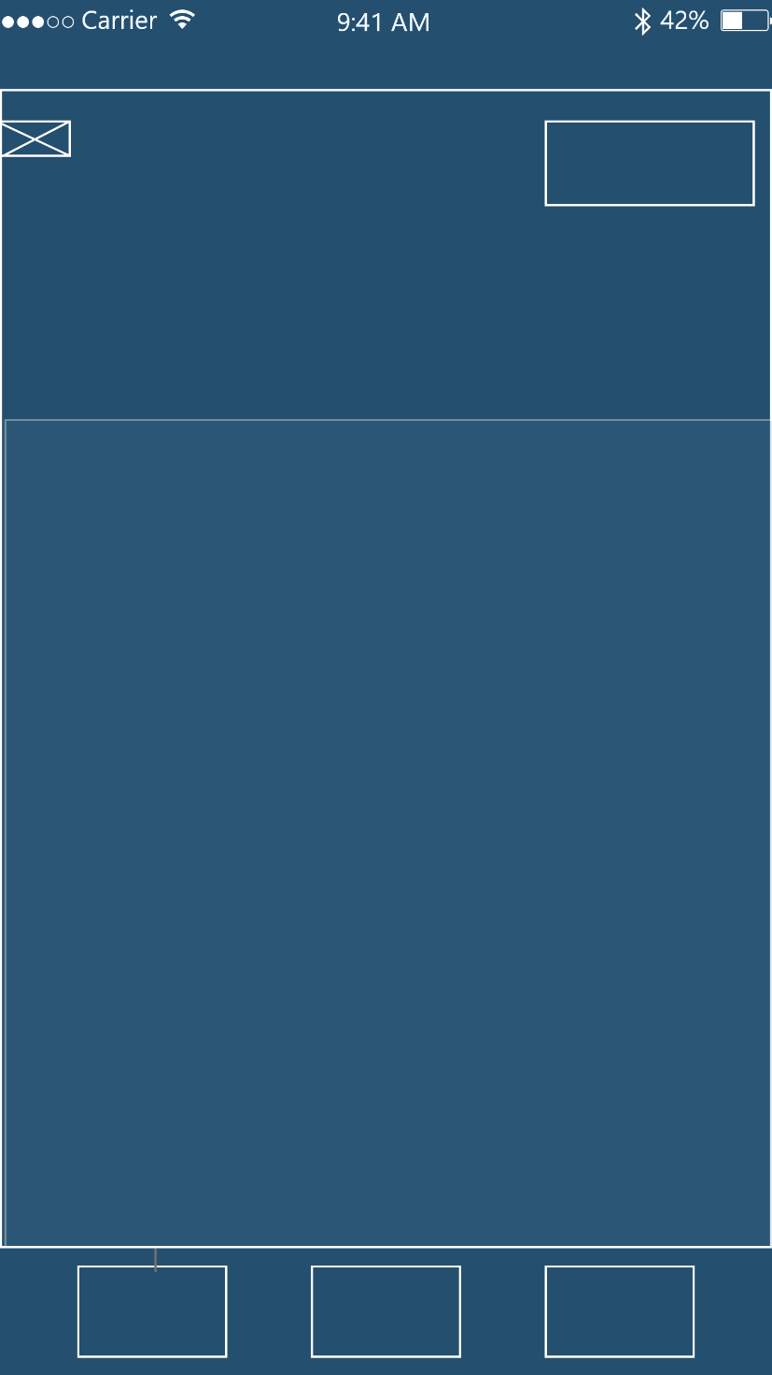

The AR plane where users can then place items from a real-world view of their camera.

A selectable button that once clicked, will show the relevant restaurant menu with products for the user to select and place onto the given AR plane.

A clear button to clear all instances of items on a plane.

The Home Menu button.

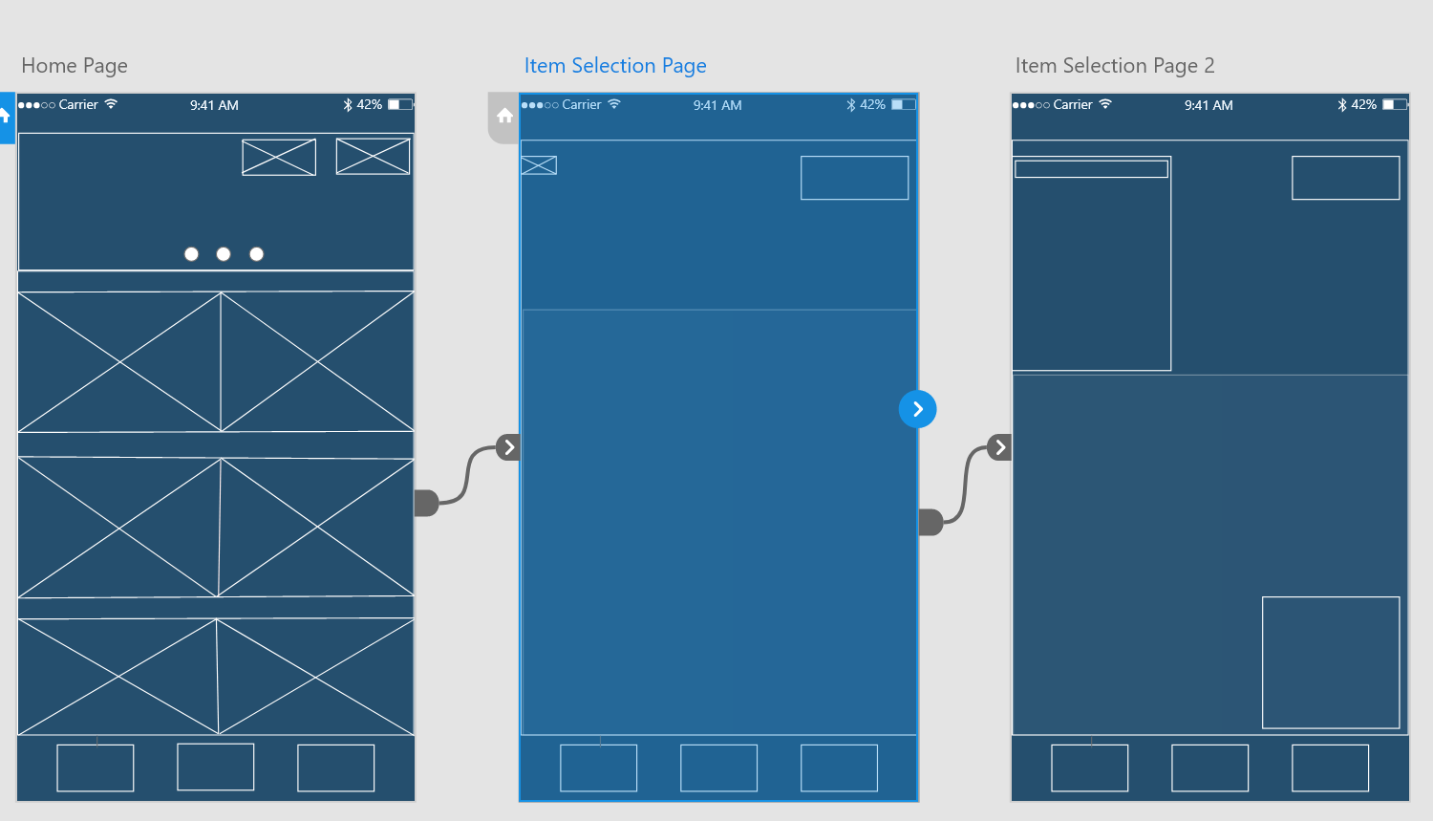

The interactions between the Home Page and the ‘Item Selection Page’. This also showcases the hierarchy between the relevant pages, as the Item Selection Page 2 arrives from selecting items from the original ‘Item Selection Page’.

# **Item Selection Page 2**

A continuation from Item Selection Page 1 (not as a new page, but existing to showcase the functionality of the application once certain buttons are pressed).

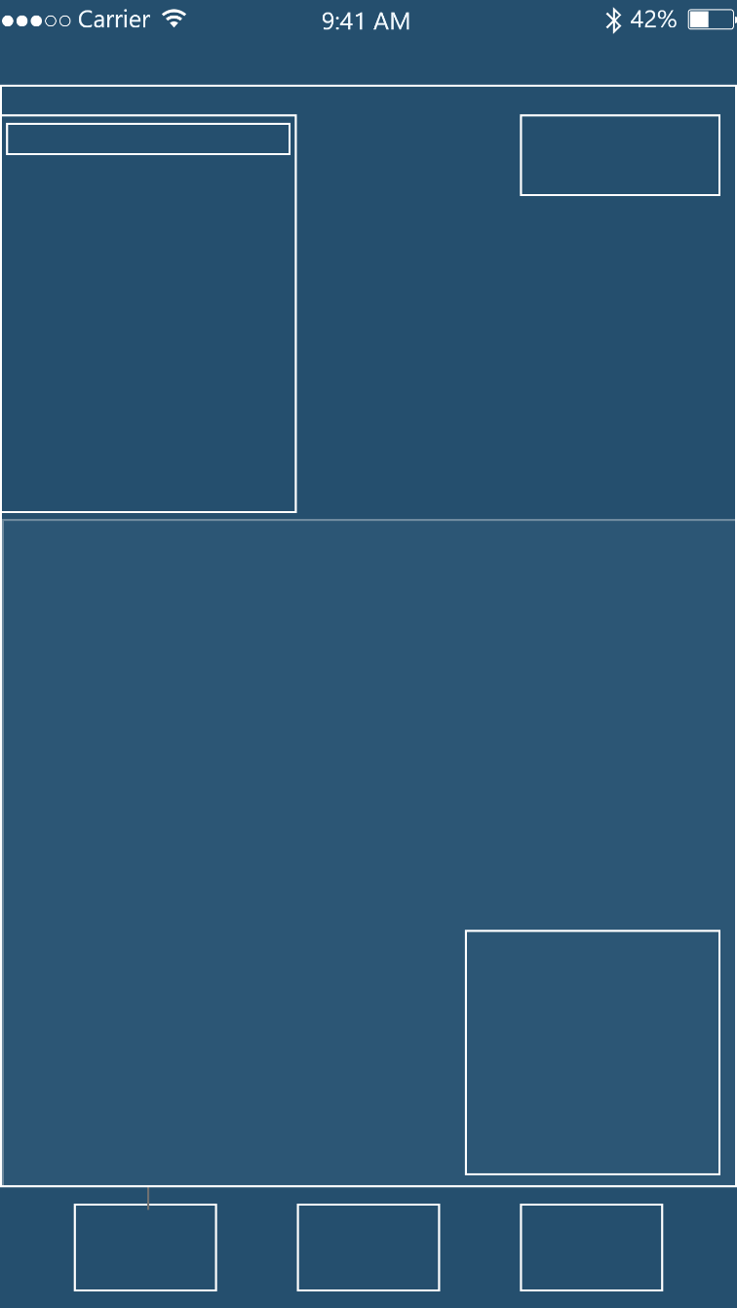

A brief description of the product – this could include what’s inside the product or just a general product overview.

The clear button.

From the first selection page button, once clicked, the menu itself will appear. Users can select a menu item and see an associative price attached to that item.

The Home Menu button.

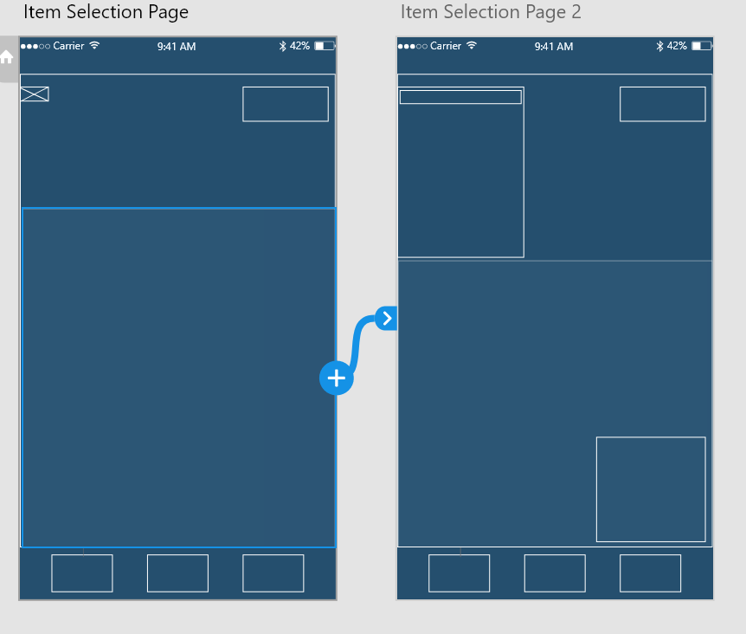

The interaction between the Item Selection Page and Item Selection Page 2.

It’s clear to see that Item Selection Page 2 is not actually a new page but for the purpose of functionality and implementation references, splitting these up into two pages will help me understand how the features of the original page should be implemented.

Examples of this is the expanded item selection button and the item description page near the bottom right of the screen.